Contents

DISPOSAL OF FIXED ASSETS
Instructions for completing the eDisposal Form

Surplused Assets - SU

Surplus Pick-Up

Pick-Up Required

Pick-Up Not Required

Disposal of 5 or more capital assets- Use the Multiple Asset Disposal Attachment form

Non Capital Surplus Disposals

Surplus Return to Campus

Destroyed Assets - DS

Junked Assets - JK

Lost Assets - LS

Stolen Assets - ST

Traded Assets - TR

Transfer out of Fixed Assets to Another University or Agency- TO

Record of Disposed Assets

Additional Asset Information:

Transfer of Fixed Assets to Another Department on Campus

Returned/Exchanged Assets

DISPOSAL OF FIXED ASSETS

University equipment cannot be thrown away or discarded. To dispose of a capitalized $5,000+ asset, the responsible department must complete an eDisposal Capital Asset Disposal Form when the fixed asset status changes:

Surplused

Junked

Destroyed,

Lost,

Stolen,

Traded in, or

Transferred to another agency or university

The sale of fixed assets is not permitted by individuals or departments. Departments should contact Warehouse Services and Surplus Property personnel at 334-5927 with questions about proper physical disposal of an asset.

Guidelines for disposing of a non-capitalized asset (cost less than $5,000), and a UNCG Surplus Submission Form can be found on the Warehouse Services website:
http://warehouse.uncg.edu/gotsurplus

Instructions for completing the eDisposal Form

eDisposal Capital Equipment Disposal Form (former FA-13)
Before accessing and submitting the Capital Equipment Disposal Form, you must know the following information. The information can be found on your inventory reports or on Banner FFIPROC instructions , and FTVLOCN (instructions):
- Asset Barcode Number or Ptag Number
  - Barcode Example: 0XXXXXX0000 (10 digits - begins with a zero, 5 numbers, and ends with four zeros)
  - Ptag Example: N000XXXXX (9 digits- begins with N000 ends with same 5 numbers in barcode)
  - The 5 numbers are the same for the Barcode and the Permanent Tag number
- Item Description
- Serial Number
  - Located on item
  - if no serial number applies, mark as N/A)
- Location Code
  - Example: 0391LB (6 digits and alphanumeric)

- Disposal Code and associated attachment (if required)
  - Attachments
    - Acquire and scan in or create electronically before you begin the eDisposal form.
    - After submission of the eDisposal form, you will receive a Submission Conformation email from Fixed Assets.
    - Reply and attach your documentation to that confirmation.
  - Disposal Codes
    - DS: Destroyed (Fire, Water, etc.)
      - Requires an attachment: Insurance Report -or- Memo from Department Head
      - Indicate whether surplus pickup is needed
    - JK: Junked/Parts
      - Requires an attachment: Memo from Department Head
      - Indicate whether surplus pickup is needed
    - LS: Lost
      - Requires an attachment: Memo from Department Head
    - ST: Stolen
      - Requires an attachment: Police report from UNCG or municipal agency
    - SU: Surplused
      - No attachment required
      - Indicate whether surplus pickup is needed
    - TO: Transferred Out (To other agency or University)
      - Requires an attachment: Memo to University Controller's Office from Department Head
        - NOTE: When transferring BETWEEN UNCG departments - use the FA-14 Equipment Transfer Form
    - TR: Trade In (see Purchasing site for details on Trade-ins)
      - Requires an attachment: Purchasing trade-in approval letter
- If Surplus Pick-Up required, Actual Physical Location of Asset

Open eDisposal link:
Capital Equipment eDisposal Form

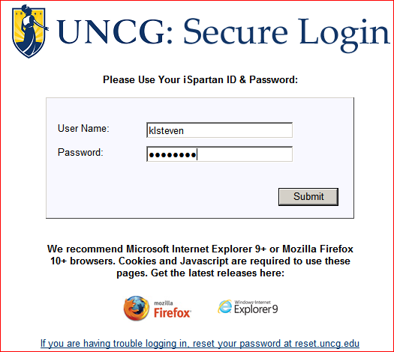

Use your UNCG Log-In.
After Log-In, default fields are auto-filled:
- Your name
- telephone number
- email address
- department name
You will fill in:
- organization number
- organization head name
- organization head email address
- asset barcode or Ptag number
- description of item being disposed (including model # and manufacturer)
- serial number
- location code of item being disposed
- select a disposal code and pick-up required

See Form Example Below:
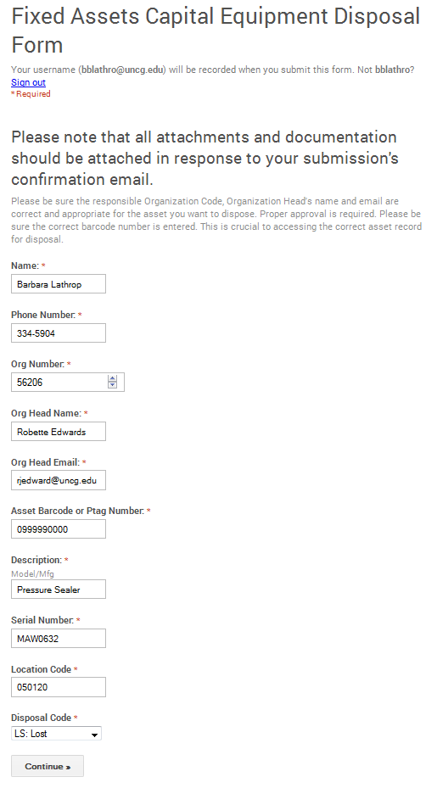
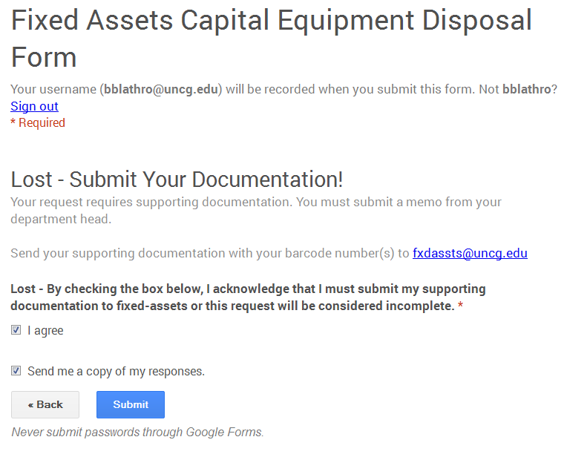
After submitting you will see this message: The screen gives you the opportunity to submit another request or close window and logout.

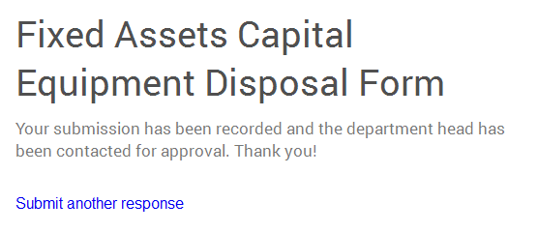

When the eDisposal form is submitted, an “Action Required” email will be sent automatically to the department head for approval and should be copied to the person submitting the eDisposal form.

Sample email sent to department head:
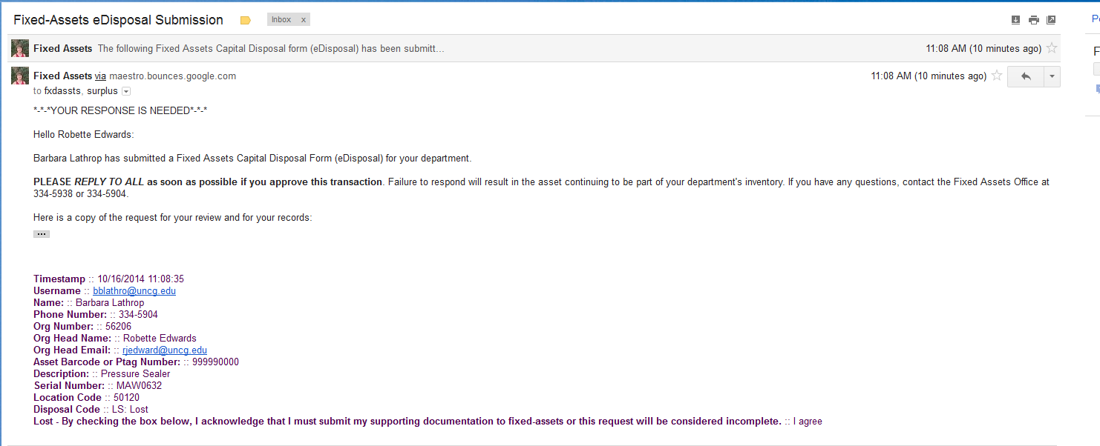

When the department head receives a “Your Response is Needed” email, he/she should Reply to All as soon as possible noting his/her approval, and CC: the designee. If the Reply to All option is not available, they should forward the email to fxdassts@uncg.edu and surplus@uncg.edu and CC: the designee.

If the department head does not respond, no further action is taken by Fixed Assets and the asset will remain on the department’s inventory.
The person submitting the eDisposal will receive a Submission Confirmation email of “Fixed Assets Capital Disposal (eDisposal). See example below. These will be replied to with attachments. It could be saved to an email file for eDisposals.
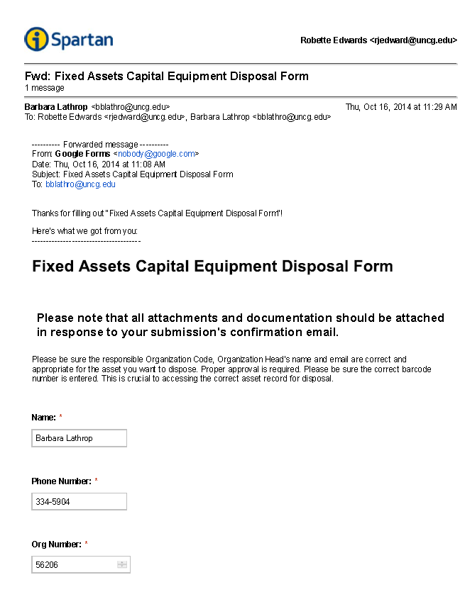

Example of Department Head approval of a disposal for a capitalized asset:
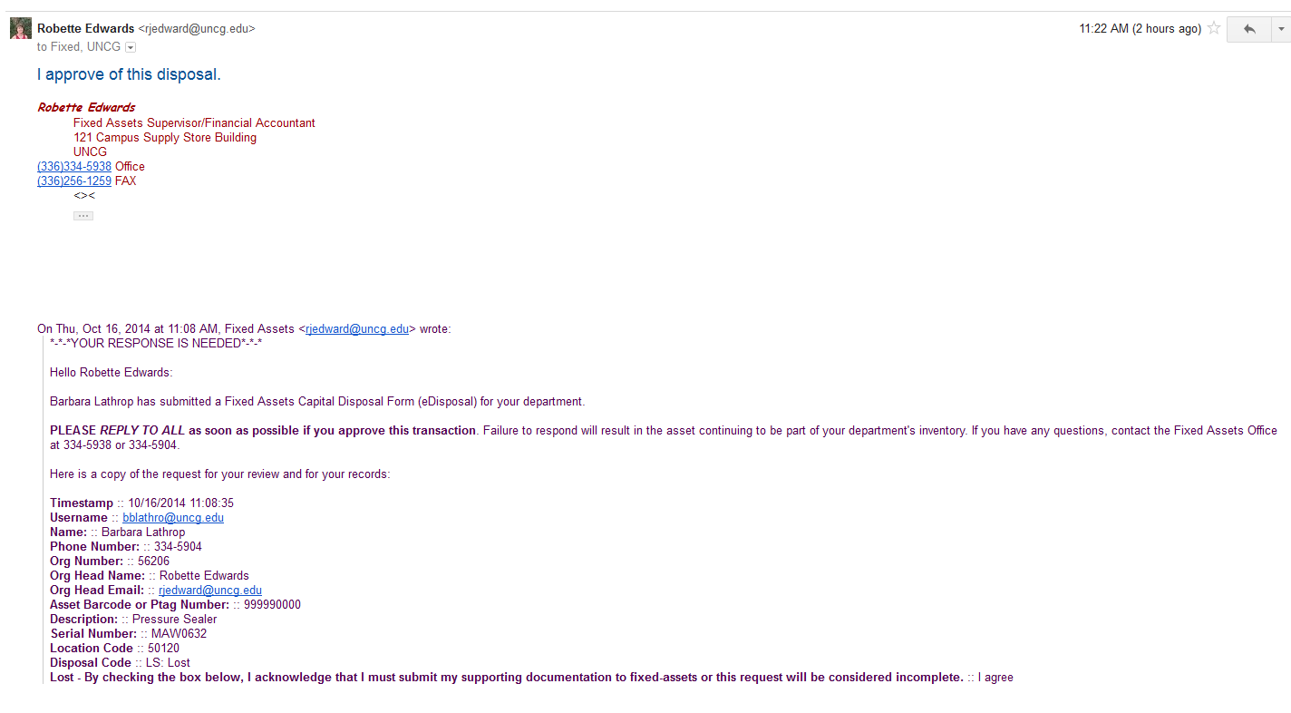
The Fixed Assets staff will check to see if the person approving the disposal is the authorized department head for the asset being disposed.

If it is not the appropriate person, the Fixed Assets staff will email the person who submitted the eDisposal (and the Warehouse) to let them know that the appropriate person has not approved the disposal and that it cannot be disposed.

Surplused Assets - SU
When an asset is considered to have no useful value to any department at the University, it may be surplused by the department. The asset may or may not have value to someone other than the University.

- The department must submit an eDisposal Equipment Disposal Form to surplus a capitalized asset.
- When a capitalized asset has been sent to the Warehouse or picked up by the Warehouse, the Warehouse will scan it.
- Bi-weekly, Fixed Assets will match the scans to the documentation to identify the assets to transfer to org code 57604 Warehouse Operations and location code 097000 for the Warehouse.
- Once transferred, the asset will no longer be recorded on the department’s inventory
- Assets will be on the Warehouse Operations inventory and inventoried annually until it is physically disposed (sold or properly destroyed).
- After a capitalized asset is properly sold or disposed, the Warehouse will record the physical disposal date on the scanner.
- Fixed Assets staff will use sale date to record as disposed on the Fixed Assets System and it will no longer be on Warehouse Operations inventory.
- Regardless of cost, all University property must be disposed through University Warehouse personnel. Under no circumstances should anyone remove University property tags and/or dispose of any fixed assets belonging to the University.

Email Flowchart for Surplused

Surplus Pick-Up
When pick up is required, approval emails are sent to the Warehouse and to the Fixed Assets office for the following disposal codes: SU, DS, JK

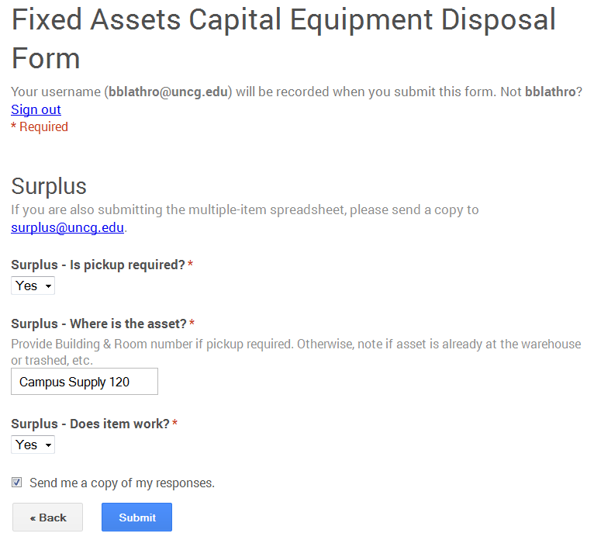

Pick-Up Required
The Warehouse Services Manager will contact the department to make arrangements for the pickup, after receiving the department head approval email.

Example of approval email sent to Warehouse (surplus) and to Fixed Assets:
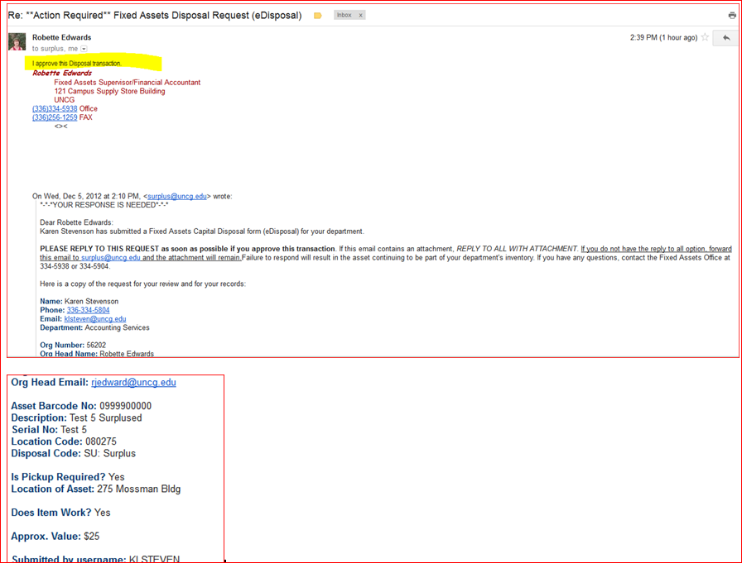

Pick-Up Not Required
The department may also make arrangements to deliver items to the Warehouse by contacting the Warehouse Services Associate.

Delivery of surplus assets to Warehouse Operations
Before:
- Complete the proper eDisposal form for capitalized assets (assets on your inventory) or
- UNCG Surplus Submission form for items not on your inventory.

Warehouse personnel need this information to accept physical custody of capitalized assets and properly track the physical disposal of capitalized assets.

The department is responsible for following proper disposal procedures.

Delivery by department with the properly completed eDisposal form
- The department may want to ask the Warehouse to sign the confirmation email showing that physical custody of the capitalized asset has changed to the Warehouse.

Delivery without the properly completed eDisposal form

- will result in the asset remaining on the department’s inventory and
- will be a missing item during the physical inventory process

Delivery by outside vendor with the properly completed eDisposal form

- The department should complete the eDisposal for items delivered to Warehouse by an outside vendor.
- Outside vendors are not responsible for the eDisposal form.
- Neither the Warehouse staff nor the Fixed Assets staff is responsible for searching for capitalized assets in a large disposal sent to the Warehouse without proper documentation.

Disposal of 5 or more capital assets- Use the Multiple Asset Disposal Attachment form
.
- Use generic Asset Barcode No: 0999990000 in the eDisposal form and Multiple in Asset description.
- Type the individual assets information required on the Multiple Asset form.
- Attach it when replying to Submission Confirmation email, and cc: Your Department Head.
- Email approval from the organization head signifies approval for all disposals on the attachment.

Multiple Asset Disposal Attachment Form

Non-Capital Surplus Disposals
Guidelines for disposing of a non-capitalized asset (cost less than $5,000), and a UNCG Surplus Submission Form can be found on the Warehouse Services website:
http://warehouse.uncg.edu/gotsurplus

Surplus Return to Campus
If another department goes to the Warehouse and wants to take physical custody of a capitalized asset in the disposal process,
- Warehouse personnel will initiate and sign an FA-14 Equipment Transfer Form.
- The New Location information should be completed by the department receiving the asset with Department Head signature.
- The signed FA-14 Equipment Transfer Form should be sent to the Fixed Assets staff for processing which will move the asset to the new department’s inventory.

Destroyed Assets - DS

When an asset was destroyed by fire, water, etc., the department must submit an eDisposal Equipment Disposal Form with supporting documentation. Attach documentation when replying to Submission Confirmation email, and cc: your Department Head, marking for pick-up, if appropriate.

No Surplus Pick-up Required
- If completely Destroyed capitalized assets have proper documentation, they will be removed from the Fixed Assets System.

Surplus Pick-Up Required
- Any portion or shell of a destroyed asset remaining should be sent to the Warehouse for proper disposal.
- Contact the Warehouse Services Associate if you have questions.
- Destroyed capitalized assets which have proper documentation will be transferred to the Warehouse inventory, if pick-up is required.

Example of Destroyed Documentation-Sample 1
Example of Destroyed Documentation-Sample 2
Example of Destroyed Documentation-Sample 3
Email Flowchart for Destroyed

Junked Assets - JK

When an asset is considered to have no useful value to any department at the University, it may be retained by the department for parts.
The department must submit an eDisposal Equipment Disposal Form with supporting documentation. Attach documentation when replying to Submission Confirmation email, and cc: Your Department Head, marking for pick up, if appropriate.

No Surplus Pick-up Required
- Junked for parts capitalized assets which have proper documentation and do not go to Warehouse Surplus will be recorded as disposed on the Fixed Assets System.

Surplus Pick-Up Required
- Any portion or shell of a junked asset remaining should be sent to the Warehouse for proper disposal. Contact the Warehouse Services Associate if you have questions.
- Junked for parts capitalized assets with proper documentation which are surplused to the Warehouse will be transferred to the Warehouse inventory, if pick-up is required.

Example of Junked for Parts Documentation
Email Flowchart for Junked for Parts

Lost Assets - LS

When an asset is lost (not stolen) the department must submit an eDisposal Equipment Disposal Form with supporting documentation. Attach documentation when replying to Submission Confirmation email, and cc: Your Department Head.

- Lost capitalized assets with proper documentation will be recorded as disposed on the Fixed
Assets System.

Example of Lost Documentation
Email Flowchart for Lost

Stolen Assets - ST
According to General Statute 114-15, if any state property has been stolen:
- The employee discovering the suspected theft must report the theft to his/her supervisor within 24 hours.
- The supervisor must notify the head of the department within the next 24 hours.
- The department head should notify the University Police at the University of North Carolina at Greensboro or municipal police department if off campus, within the following 24 hours.
- The University Police should be notified as soon as possible, but no later than three days from the day of discovery.

When an asset is stolen, the department must submit an eDisposal Equipment Disposal form. Attach documentation when replying to Submission Confirmation email, and cc: your Department Head.

- A copy of the University Police or municipal report pertaining to a theft and containing the asset description, serial number, and/or barcode number.
- Stolen capitalized assets with proper documentation will be recorded as disposed on the Fixed
Assets System.

Example of Stolen Documentation
Email Flowchart for Stolen

Traded Assets - TR
A replacement asset may be acquired when an existing asset is traded to the vendor as partial payment on the new item.
- The Purchasing Office must approve the item being traded. See Purchasing Policy 4.20 for instructions.
- The department must submit an eDisposal Equipment Disposal Form for trade-ins when the physical custody of the asset changes to the vendor.
- Attach documentation when replying to Submission Confirmation email, and cc: Your Department Head.

Traded-in capitalized assets with proper documentation will be recorded as disposed on the Fixed Assets System.

This same traded-in asset information should be put into the eMarketplace Trade-In Form and inserted into the 1st requisition line on the new asset requisition.

Example of Traded In Documentation
Email Flowchart for Trade-In

Transfer out of Fixed Assets to Another University or Agency- TO

When a department wants to transfer a capitalized asset to another agency or university:
- The department needs the approval of the University Controller and the Contracts and Grants Officer (if purchased with grant funds).
- The department will submit an eDisposal with a memo from the department head that contains a list of the equipment bar codes, descriptions, and serial numbers. Attach documentation when replying to Submission Confirmation email, and cc: Your Department Head.
- An email will be sent to the University Controller for his approval.

Transferred to another university or agency capitalized assets with proper documentation will be recorded as disposed on the Fixed Assets System.

Example of Transfer-Out Documentation
Email Flowchart for Transfer Out

Record of Disposed Assets

The Fixed Asset System includes a file of disposed assets as inactive items on the Master File. The Master File is a listing of all University property, which meets the Capitalized Fixed Asset Fixed Asset criteria.
- The Fixed Asset Section maintains the Master File. Entering the appropriate codes on the Disposal Screen moves the item to inactive.
- Disposed assets remain on the Fixed Asset System until purged.
- If a department has any questions about a previously disposed item, please contact the Fixed Asset Section.

Additional Asset Information:

Transfer of Fixed Assets to Another Department on Campus

Transfers are defined as the movement of equipment from one department to another.
- If the department does not change, it is only a location change.
- Equipment may be transferred from one department to the other when no longer needed using FA-14, Equipment Transfer Form.

FA-14 Fixed Assets Transfer Form

- An equipment swap may be initiated on Warehouse Services Swap Shop.
- Any capitalized asset swapped must have an FA-14 Equipment Transfer Form completed and sent to the Fixed Assets Office.

Returned/Exchanged Assets

If the department returns an asset which has been bar coded to the vendor, the department should:

- Contact the Fixed Assets Supervisor at 334-5938 and
- Provide a copy of the credit memo or check received from the vendor.

If the department exchanges an asset that has been bar coded for a replacement asset:

- The department should provide Fixed Assets Office with documentation of the RMA, which should include the vendor’s reference to the exchanged asset’s serial number and its replacement serial number.
- Upon receiving this documentation, a Fixed Assets staff member will apply a barcode of the replaced asset number to the new equipment and update the serial number in the Fixed Assets record.

