Instructions for Finding a Location Code – FTVLOCN

In Banner: Go to Form: FTVLOCN
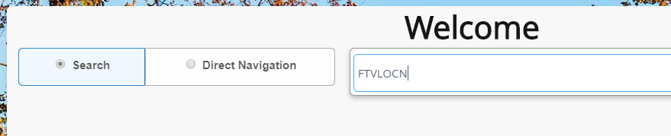
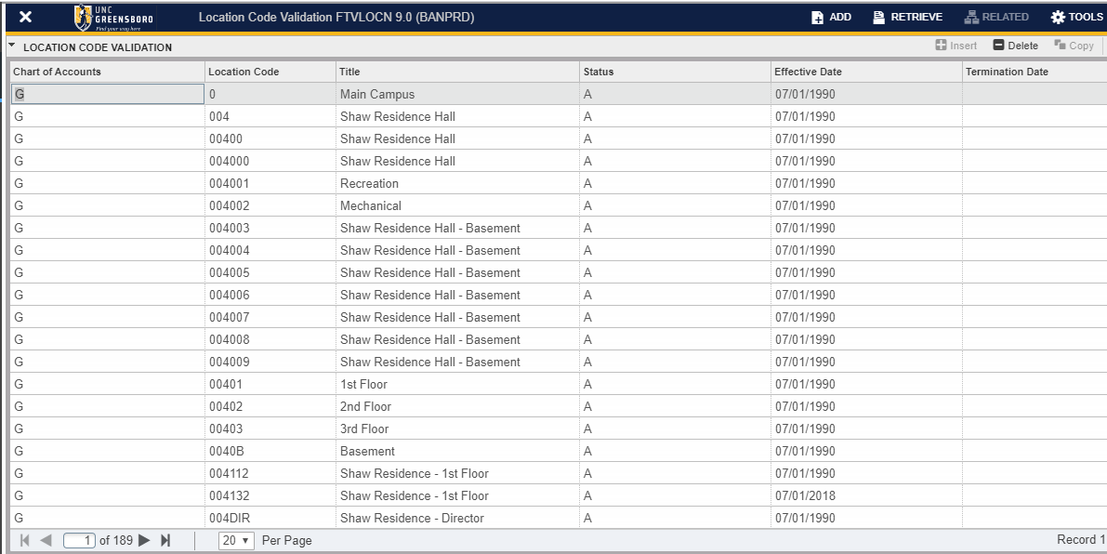
Select Filter or hit F7 to Query a specific Location
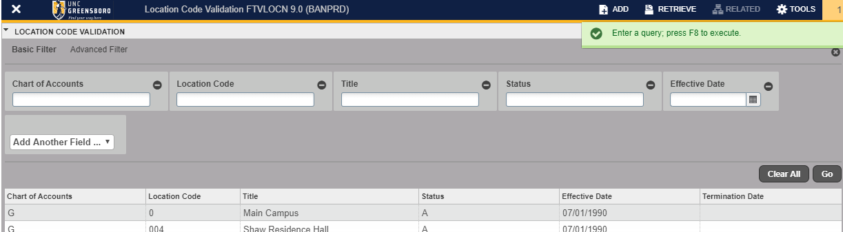

To find a location by Building Name
In Title field, input %name of the building (case sensitive)%.
Select Go or F8
- Example: %Curry%
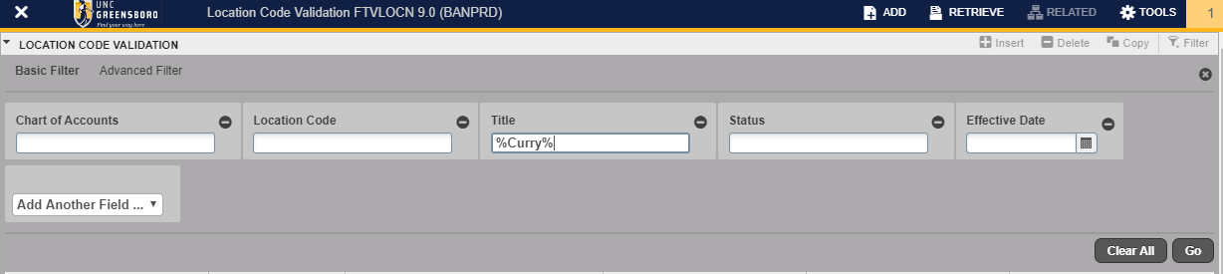

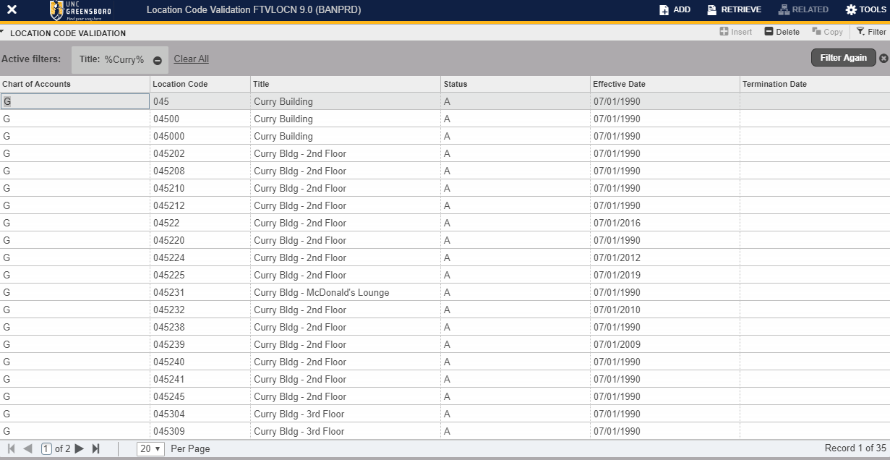

The first 3 digits are the Building Number, and the last 3 digits are the room number. This is a query function and could result in relevant and non-relevant results.

To find a location by Building Code
Filter or F7 to Query
If you know your 3-digit building code, you may enter a query in the Location Code.
Select Go or F8
- Example: %045%
